

Software Engineering Department
Braude College of Engineering
Capstone Final Project – Phase A (61998)
Robot Eco Farm
26-1-R-6
By:
Israel Ohayun Israel.Ohayun@e.braude.ac.il
Advisor:
Dr. Naomi Unkelos-Shpigel
Mr. Uzi Rosen
Link to GitHub:
https://github.com/xsrel77/Ronen-Autonomous-Vehicle-

Abstract
Robot Eco Farm is an autonomous 4×4 greenhouse rover for monitoring lettuce health in a community greenhouse in Karmiel. The system combines a low-power Raspberry Pi 5 (5V/5A) with a Hailo-8 edge AI accelerator, a camera, and 2D LiDAR to navigate greenhouse rows and produce actionable monitoring outputs. The research focus is the feasibility of achieving reliable autonomous sensing and decision support under strict power and compute constraints, where real-time perception, navigation, and communication must run on a limited embedded platform. The rover performs repeated scan missions inside narrow greenhouse beds and detects relevant targets such as lettuce condition indicators, diseases, weeds, obstacles, people, and safety-related events. Perception and navigation outputs are converted into structured events, which are uploaded to a web dashboard via a REST API. Because greenhouse connectivity can be intermittent, the system includes buffered delivery and a fixed JSON export format to ensure consistent and recoverable data reporting. The platform is designed to support long missions on portable power while maintaining predictable performance and resource usage. Success is evaluated using acceptance criteria that reflect both operational and research goals: scan time per greenhouse section, data completeness per mission, communication latency and reliability, and Phase B perception performance (mAP@0.5, precision, and recall). The expected contribution of this work is a validated end-to-end approach for greenhouse monitoring that demonstrates how an embedded 5V/5A edge-AI platform can support autonomous rover operation, while documenting the system trade-offs between power, compute load, and monitoring quality.

1. Introduction
1.1 Problem Statement: Non-precise greenhouse farming (weeds, lettuce diseases, rot)
1.2 Related Work: Smart/precision agriculture examples and identified gap
1.3 Project Aim and Contribution: 4x4 robot scanning rows and real-time web updates

2. Background and Literature Review
2.1 The Community Farm in Karmiel: context and needs
2.2 Weed and Disease/Rot Detection in Leafy Greens (Lettuce)
2.2.1 Visual Targets in the Greenhouse (Lettuce Varieties, Weeds, and Rot)
2.3 Precision Agriculture: concepts, sensors, and data workflows
2.4 Robotics for Precision Agriculture: directions, challenges, and constraints

3. Engineering Process
3.1 Phase A Progress
3.1.1 Figure 2: Process Infographic (end-to-end pipeline)
3.1.2 Meeting with the Customer
3.1.3 Robot Platform Build (4x4 + sensors)
3.1.4 AI Algorithm Development (detection pipeline)
3.1.5 Navigation and Localization Development (LiDAR + IMU)
3.1.6 Prototype Integration (robot ↔ server/website)
3.2 Requirements
3.2.1 Functional Requirements (FR)
3.2.2 Non-Functional Requirements (NFR) – Wikipedia-based classification
3.3 Algorithms
3.3.1 ROS
3.3.2 SLAM
3.3.3 YOLO8
3.4 Diagrams
3.4.1 Use Case Diagram
3.4.2 Architecture Diagram (robot structure, sensors, software)
3.4.3 Activity Diagram (Scan & Data Reporting)
3.5 Expected Challenges

4. Tests and Metrics
4.1 Success Metrics and Acceptance Criteria
4.2 Functional Test Plan
References
Appendices A

1. Introduction
Greenhouse lettuce cultivation is often monitored through manual inspection, which is time-consuming, inconsistent, and difficult to scale as the number of planting rows increases.
In practice, delayed detection of weeds, leaf diseases, and early rot can lead to quality degradation, yield loss, and inefficient use of resources (labor, water, and treatments).
Early identification of plant diseases is considered critical for reducing damage and preventing escalation, which motivates the development of automated, image-based monitoring approaches (Mohanty et al., 2016). The problem becomes more challenging in real greenhouse conditions where illumination changes, leaf occlusions, and narrow planting corridors reduce visibility and increase the probability of missed issues.
Recent research demonstrates the potential of smart and precision-agriculture technologies to automate crop monitoring and intervention, yet it also highlights important gaps for real-time deployment. For example, high-speed crop/weed identification in lettuce fields has been demonstrated using multispectral reflectance and kinematic stereo concepts, but robust performance under real field speed and varying conditions remains challenging (Elstone et al., 2020). In leafy-green disease management, multi-stage diagnostic systems (crop classification → health status → lesion localization) have been integrated with cloud-based decision support, showing promising results while emphasizing the need for practical end-to-end operational workflows (Abbasi et al., 2023). For lettuce health assessment, two-stage pipelines that combine detection (e.g., YOLO) with classification (e.g., EfficientNet) report strong recognition results, while still stressing the importance of validation across environments and integration into automated monitoring systems (Wang et al., 2024). In parallel, greenhouse robot navigation research proposes practical solutions for indoor agricultural platforms operating in narrow corridors, but navigation is often studied separately from crop-health sensing and real-time reporting to stakeholders (Yoo et al., 2024). Overall, the main gap is the lack of a robust, real-time, end-to-end solution that combines reliable greenhouse navigation, accurate visual detection of weeds/diseases, and immediate reporting in a deployable system.
This research-oriented final project addresses that gap by developing and evaluating an end-to-end prototype for a community greenhouse in Karmiel: a low-voltage 4×4 autonomous mobile robot that scans each planting row, detects weeds and visible lettuce issues (disease symptoms and early rot) using advanced computer-vision algorithms (YOLO-based detection), and supports safe autonomous operation using onboard perception for navigation (LiDAR/IMU-based mapping and localization). The research focus is on designing and optimizing this algorithmic pipeline under constrained edge hardware specifically a Raspberry Pi 5 combined with a Hailo-8 AI accelerator (26 TOPS) and examining whether such a low-power platform can still deliver reliable real-time performance. The system continuously uploads findings to a web dashboard, enabling the farm manager (Keren) to monitor greenhouse status remotely and respond quickly based on the robot’s reports.

2. Background and literature review
2.1 Background The Community Farm in Karmiel: Context and Needs.
The Community Farm in Karmiel is an educational–community framework that was established in 1996 to teach agricultural and environmental sciences to school and kindergarten students in Karmiel and the surrounding area. The farm operates as a municipal facility and serves as a local hub for experiential learning focused on plant cultivation, sustainability, and environmental awareness.
In practice, the farm supports a broad range of agricultural learning activities and hosts ongoing educational programs for different age groups throughout the year. Its agricultural branches include, among others, a vegetable garden, nursery, orchards, greenhouse areas, and additional plant-growing environments. In addition to its educational role, the farm’s routine work includes continuous maintenance of crops and learning spaces that must remain functional and safe for visitors and students.
Because the farm is publicly funded and operates on defined schedules, routine on-site activity is mainly limited to daytime opening hours (typically around 08:00–14:00). As a result, for most hours of the day there is no continuous human monitoring of the lettuce planters inside the greenhouse (see Figure 1). During holidays and long breaks when activity is reduced or paused the detection of critical issues (weeds, early leaf symptoms, or initial rot) may be delayed, which can accumulate into measurable yield loss and wasted labor due to late intervention.
From an engineering perspective, the greenhouse layout in this project includes six long, parallel planters with walking lanes between them, enabling systematic “row-by-row” scanning. For design and navigation constraints, the greenhouse dimensions are treated as upper bounds of up to 11 m in width and up to 24 m in total length. This structured layout enables the robot to scan the same rows on a regular schedule (e.g., daily). However, if a scheduled scan is skipped, emerging issues may grow and remain unnoticed until the next visit. Therefore, the core need in this farm context is an autonomous monitoring solution that can perform repeatable scans even when staff are not present and provide clear, timely reporting through a simple web interface for the farm manager.
Link to the website of the community farm in Karmiel:
https://www.karmiel.muni.il/residents/tarbut/%D7%94%D7%97%D7%95%D7%95%D7%94-%D7%94%D7%97%D7%A7%D7%9C%D7%90%D7%99%D7%AA/
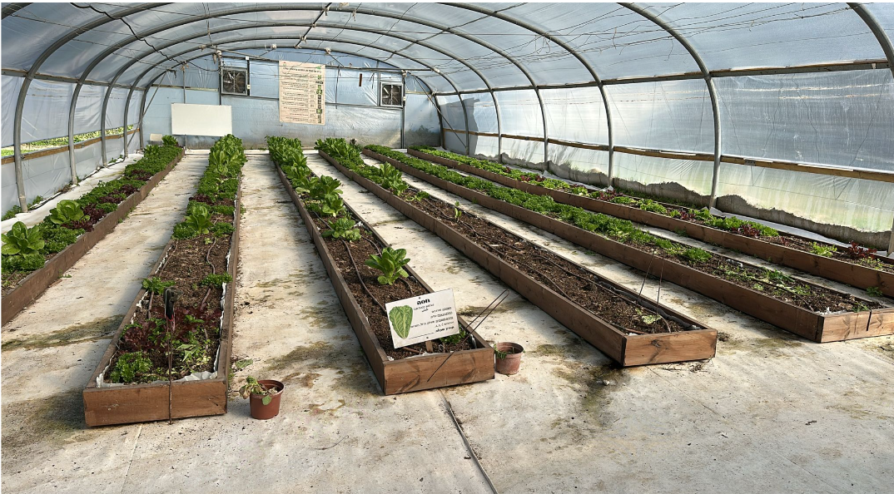
Figure 1.The greenhouse in Karmiel for growing lettuce in pots
literature review

2.2 Weed and Disease/Rot Detection in Leafy Greens (Lettuce)
Detecting weeds and visible plant-health issues in leafy greens is challenging in practice because the visual scene is highly cluttered (soil, planter edges, irrigation lines), illumination can change throughout the day, and leaves frequently occlude one another. These factors increase false detections and reduce the robustness of models when deployed outside controlled conditions.
Recent studies show that modern deep-learning detectors can perform well, but performance depends strongly on the complexity of the environment and the target characteristics. For weed detection in dense, occluded field settings, both segmentation-style methods (e.g., Mask R-CNN) and real-time detectors (e.g., YOLOv8) have been evaluated, with reported results illustrating that occlusion and complex backgrounds remain major sources of error (Goyal et al., 2025). In hydroponic lettuce monitoring, a practical approach is to combine fast object detection with a second-stage classifier: Wang et al. propose a YOLO-based detection stage to isolate lettuce instances from video frames and an EfficientNet-based classifier to identify growth/health status, reporting strong recognition performance for healthy vs. abnormal cases (Wang et al., 2024). For dense, small-object scenarios (seedlings), improvements to region-based detectors can be beneficial: (Li et al., 2021) propose an enhanced Faster R-CNN framework and report high detection performance for seedling status targets such as dead seedlings and double planting, demonstrating that tailored architectures can improve results when objects are small and crowded (Li et al., 2021).
Overall, the literature supports the feasibility of vision-based detection for weeds and lettuce health conditions, but it also indicates that reliable deployment requires addressing real-world variability (occlusion, lighting, background clutter) and designing an end-to-end workflow that turns detections into actionable greenhouse monitoring outputs (Abbasi et al., 2023).

2.2.1 Visual Targets in the Greenhouse (Lettuce Varieties, Weeds, and Rot)
In this project, the robot monitors a real community greenhouse environment where the visual scene is heterogeneous and often cluttered. The monitoring targets are defined according to the operational needs of the farm: identifying the main lettuce varieties grown in the planters, detecting weeds that emerge near the crop, and recognizing visible signs of early rot or leaf damage.
The greenhouse planters include multiple lettuce varieties with distinct visual appearance, such as red-leaf lettuce and green curly lettuce (Lalique-type), as well as larger green lettuce heads (Arabic/Romaine-type).

2.3 Precision Agriculture: Concepts, Sensors, and Data Workflows
Precision Agriculture aims to optimize farming operations through high-resolution monitoring and targeted actions (per row, planter section, or individual plant), driven by sensor data and computational models. In monitoring tasks, the value of precision approaches is the ability to detect early-stage issues, track trends over time, and reduce unnecessary interventions by focusing treatment only where it is needed.
A typical precision-agriculture workflow can be described as a data pipeline: (1) sensing and acquisition, (2) pre-processing, (3) model inference, (4) post-processing and spatial context, and (5) visualization and decision support. In practice, sensing may include RGB imagery as the primary source, and can be complemented with additional modalities (e.g., near-infrared reflectance, LiDAR, IMU, and wheel odometry) depending on the task and environment. For example, Elstone et al. demonstrate high-speed crop/weed identification in lettuce fields using multispectral reflectance together with a kinematic stereo method to improve plant localization during motion, highlighting the importance of sensing design for precision weeding applications (Elstone et al., 2020).
Beyond detection alone, precision agriculture systems increasingly emphasize integration and operational decision support. Abbasi et al. present a multi-stage disease diagnosis workflow for leafy green crops that is connected to a cloud-based application and knowledge support, illustrating how automated detection can be linked to management actions and reporting (Abbasi et al., 2023). In parallel, remote-sensing research shows how machine learning can be used to estimate plant physiological indicators using UAV-based hyperspectral imaging, reinforcing the broader precision-agriculture perspective that “health” can be inferred from data-driven models rather than manual observation alone (Fishman et al., 2025).

2.4 Robotics for Precision Agriculture: Directions, Challenges, and Constraints
Robotics for precision agriculture requires the integration of repeatable navigation with reliable sensing and inference. In greenhouse environments, the workspace is typically narrow, structured, and GNSS(Global Navigation Satellite System)-denied, which makes localization and safe motion planning central engineering requirements. Consequently, many robotic approaches focus on row-wise traversal, accurate path following, and obstacle-aware motion in confined corridors.
For greenhouse navigation, Yoo et al. present an indoor shuttle-robot approach that relies on LiDAR-based mapping and a path-following framework suitable for structured greenhouse routes, illustrating a practical direction for autonomous movement where GPS is unavailable (Yoo et al., 2024). At the localization layer, 2D LiDAR SLAM remains a common choice, but algorithm selection involves trade-offs between accuracy and computational cost. Li and Zhu compare representative 2D LiDAR SLAM algorithms (Hector, GMapping, Cartographer) under simulated orchard-like environments and evaluate them using localization/mapping error and resource usage, demonstrating that performance depends on both the algorithm and environmental characteristics (Li & Zhu, 2024).
A further constraint in community and educational environments is safety around people. For mobile robots operating in spaces where visitors may be present, it can be valuable to detect and track humans using onboard sensors; for example, people-tracking from 2D LiDAR scans using full convolutional neural networks has been explored for cluttered environments, supporting the feasibility of LiDAR-based human awareness as an additional safety layer (Guerrero-Higueras et al., 2019). Taken together, these works motivate an integrated robotic monitoring system that combines repeatable row-wise navigation, robust perception, and real-time reporting—especially under edge-computing constraints typical of low-power platforms.

3. Engineering process
3.1 Phase A Progress
3.1.1 Figure 2: Process Infographic (end-to-end pipeline)
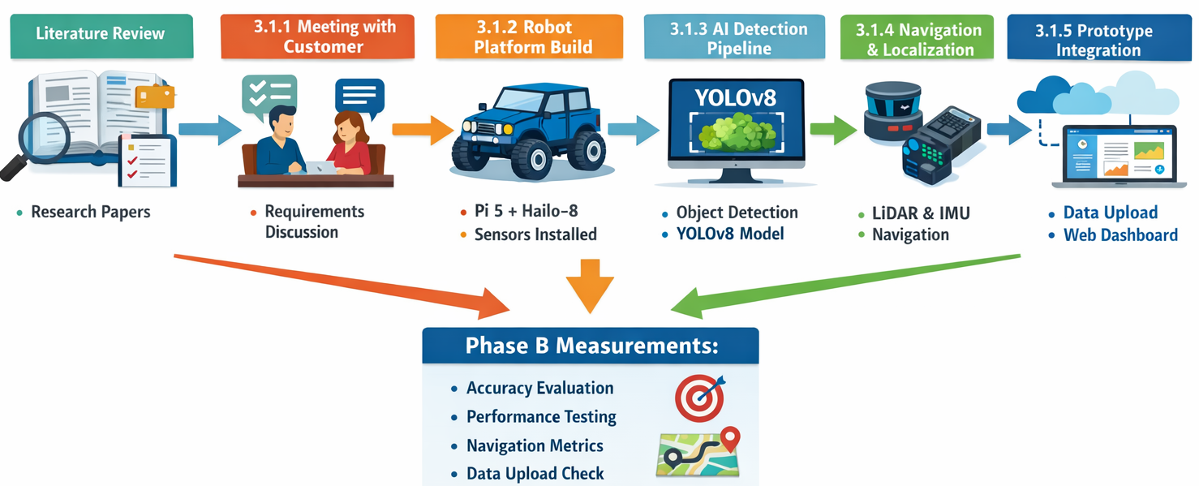
Figure 2. Phase A End-to-End Pipeline

3.1.2 Meeting with the Customer
Phase A started with a customer meeting to understand the real operational needs in the community greenhouse in Karmiel. The greenhouse manager, Keren, introduced the project goals and then referred us to an in-depth on-site interview with the greenhouse operational manager, who is responsible for day-to-day maintenance and practical field decisions.
Greenhouse context and crops. During the walkthrough, the operational manager explained that the greenhouse grows lettuce and pointed out multiple varieties in the planters (including curly lettuce “Lalik” and red lettuce). These examples helped define what “healthy lettuce” looks like in real conditions and supported later decisions on dataset labeling and detection classes.
Main problems observed in the beds (what must be detected). The operational manager highlighted recurring issues that require manual intervention and can damage yield:
- Soil/bottom rot: described as rot that starts from the lower parts of the plant, often related to water accumulation in parts of a planter.
- Pest-related leaf damage: leaf holes and damage attributed to pests such as larvae or small slugs/snails, sometimes appearing inside the lettuce heart.
- Weeds: weeds appear regularly between lettuce plants and require repeated removal.
- Severe infestation case: a heavy ant infestation was described in a specific planter, creating a food-safety concern and reducing harvest quality.
Evidence from the field visit.
Photos taken during the meeting document examples of weeds and abnormal plants and are included in this report as
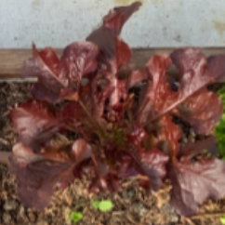 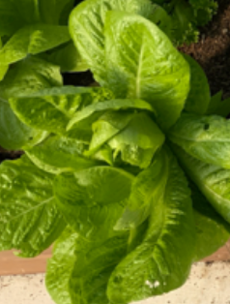 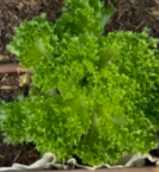
Figure 3. Representative lettuce varieties in the greenhouse
Figure 3a presents Lalique Lettuce
Figure 3b presents Red lettuce
Figure 3c presents Arabic lettuce

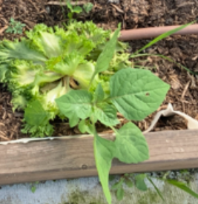 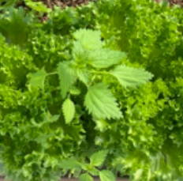 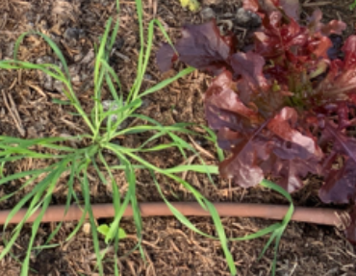
Figure 4. shows typical weed growth patterns observed in the greenhouse, including broadleaf weeds and grass-like weeds emerging between lettuce plants.
Figure 4a presents The nettle plant
Figure 4b presents The nettle plant
Figure 4c presents grass

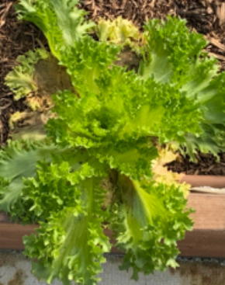 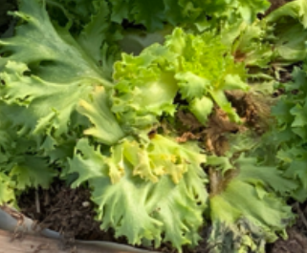
Figure 5. provides examples of rot/deterioration cases in Lalique Lettuce observed during Phase A
Figure 5a presents The deterioration of Lalique lettuce leaves
Figure 5b presents Rot from the soil in the lettuce plant

The operational manager explained that greenhouse maintenance is not performed continuously throughout the day, and conditions can change between visits. This supports the need for an automated monitoring solution that scans systematically and reports problems early, rather than relying only on manual inspection.
Implications for system design.
The interview produced design guidance that shaped Phase A:
- Findings must be linked to a specific planter/row location to enable targeted action.
- Visual monitoring must handle greenhouse constraints such as lighting variation and leaf occlusions.
- Data collection should prefer consistent viewpoints aligned with how the robot approaches the planters, to improve training and deployment match.
In summary, the customer meeting and the operational interview defined the field-driven scope of the project: detect weeds and visible lettuce issues (including rot symptoms and pest-related damage) per planter/row, and produce structured outputs that can be uploaded and presented to Keren for daily operational decision-making.

3.1.3 Robot Platform Build (4×4 + sensors)
Platform Overview
The robotic platform was built by integrating two existing systems: the Machina Climbing Car Pro 4×4 base (drivetrain and chassis) and the Raspbot V2 kit (robotics electronics and expansion board). Mechanically, the original upper body of the 4×4 vehicle was removed, and the Raspbot V2 structure (without its original wheels) was mounted onto the 4×4 chassis. This approach provides a robust drivetrain for greenhouse floor conditions while maintaining a modular robotics stack for sensing, actuation, and computing.
(see Figure 6) presents the full component layout of the rover, including the main computing unit, AI accelerator, sensors, communication module, and teleoperation device. (see Figure 7) highlights the custom mechanical add-ons developed to adapt the platform for greenhouse scanning.
Core Computing and Edge-AI Acceleration
The main onboard computer is a Raspberry Pi 5 (8 GB RAM). It runs the high-level software stack, including perception, navigation logic, and reporting. To support real-time computer-vision inference on an embedded platform, the rover includes a Hailo-8 AI accelerator (26 TOPS) connected to the Raspberry Pi via PCIe (see Figure 6). This configuration is intended to enable YOLO-based detection under limited power and compute resources.
Power and Cooling
Power is supplied by a 7.4 V / 2000 mAh battery that feeds the expansion board and, through it, powers the Raspberry Pi 5 and the Hailo-8 accelerator. The LiDAR unit is powered separately by an external 5 V / 1000 mA supply. Active cooling is provided by the Raspbot V2 fan to improve thermal stability during extended runs.

Low-Level Control and Actuation
The DC motors of the 4×4 chassis are driven through the Raspbot V2 expansion board (see Figure 6). Based on the markings observed on the main controller chip (STC8 family), the expansion board is built around an STC microcontroller (STC8 series), responsible for real-time low-level hardware interfacing and actuation control. This division of responsibilities enables stable motor control at the microcontroller level while the Raspberry Pi focuses on high-level processing tasks.
At the interface level, the Raspberry Pi communicates with the expansion board using I²C, and devices attached to the expansion board (including DC motor control and camera servos) are controlled through this I²C-based subsystem.
Sensors for Greenhouse Perception and Navigation
The rover integrates sensors required for greenhouse scanning and safe navigation (see Figure 6):
- Camera (IMX219, 8 MP): Connected via CSI ribbon cable and mounted on a pan–tilt mechanism powered by two micro servos, enabling controlled viewpoint changes and consistent coverage of planter rows.
- IMU: Provides motion-related measurements (acceleration and angular rate) to support motion estimation.
- 2D LiDAR (YDLIDAR T-mini Pro Plus): Provides 2D range scans for obstacle avoidance and spatial awareness; connected via a serial interface.
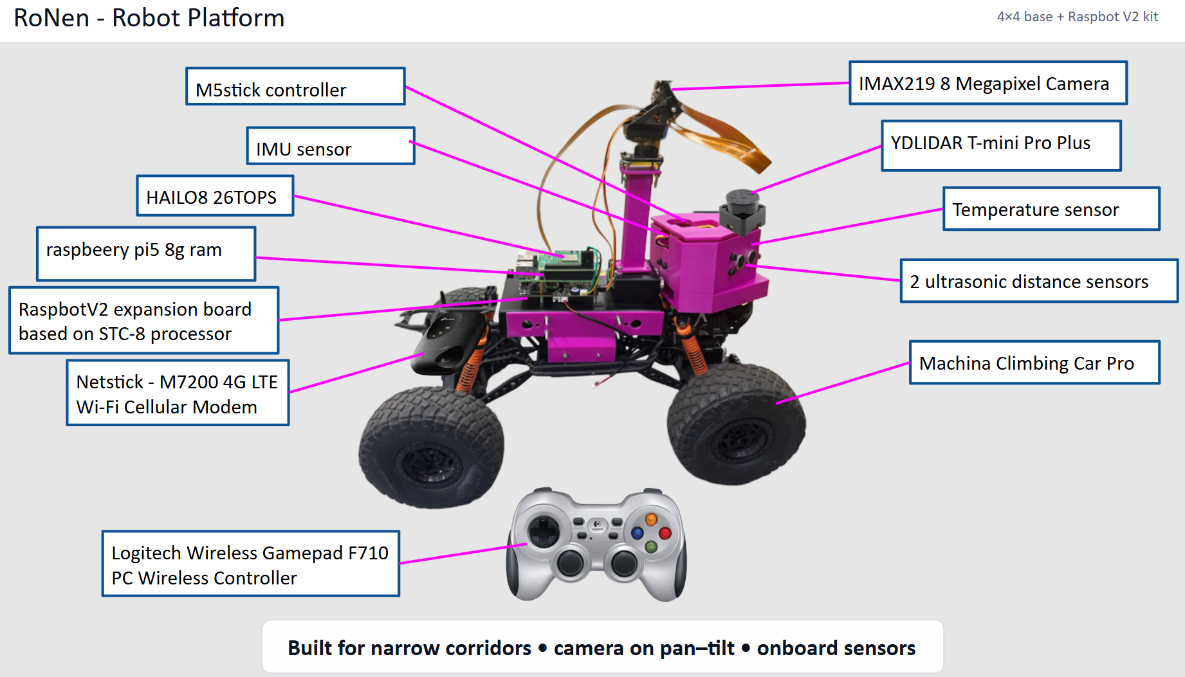
Figure 6. Robot platform component overview: Raspberry Pi 5 + Hailo-8 edge AI, IMX219 camera on pan–tilt, 2D LiDAR, IMU, ultrasonic sensors, LTE modem, and teleoperation gamepad integrated on the Machina 4×4 base.

Communication and Teleoperation
For deployment and safe testing, the rover supports both remote connectivity and local manual control (see Figure 6). A 4G LTE Wi-Fi modem provides cellular connectivity for real-time data upload and remote monitoring. For teleoperation in safety-critical situations, a Logitech F710 wireless gamepad is used for manual control during tests.

Mechanical Engineering Add-ons for Field Deployment
A key part of the platform build was a collaboration with Mechanical Engineering students who developed custom mechanical structures to adapt the rover to greenhouse constraints (see Figure 7):
- Camera mast (elevation mount): Raises the camera to improve coverage and enable a more top-down viewpoint during scanning.
- Chassis brackets (connector brackets): Mechanically connect the Raspbot V2 body to the Machina 4×4 platform, improving stability and simplifying assembly.
- Sensor enclosure: A protective 3D-printed housing designed to mount front-facing sensors and provide safer integration in the greenhouse environment.
- M5Stick-based sensing module: An auxiliary module that integrates two ultrasonic distance sensors, a temperature sensor, and an IMU. The module was designed to offload selected sensing and preprocessing tasks from the Raspberry Pi when computer-vision inference and navigation run concurrently.
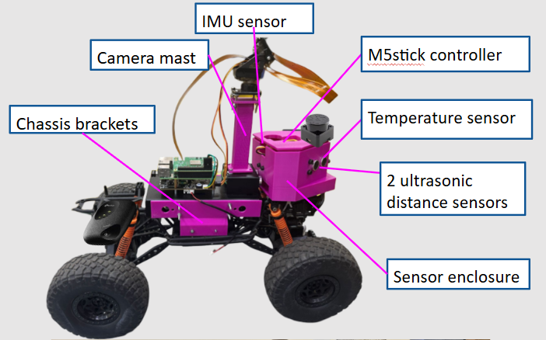
Figure 7. Mechanical Engineering add-ons developed for greenhouse scanning: camera mast (elevation mount), chassis connector brackets, sensor enclosure, and an auxiliary M5Stick-based sensing module.

3.2 Requirements Functional Requirements (FR)
Area | FR (Atomic)
Field Operation | 1. Robot scans corridors row-by-row.
Field Operation | 2. Robot creates a greenhouse map during scanning.
Perception (Detection) | 3. Robot detects: Person, Healthy Lettuce, Leaf Disease, Weed, Soil Rot.
Events | 4. Robot logs abnormal events when Weed or Leaf Disease is detected.
Navigation & Localization | 5. Robot centers in corridor (LiDAR).
Navigation & Localization | 6. Robot stops on obstacle.
Integration & UI | 7. Robot uploads abnormal events.
Integration & UI | 8. Robot stores logs locally.
Integration & UI | 9. Robot displays events on web dashboard.
Integration & UI | 10. Robot supports manual teleoperation.
Edge AI / Security | 11. Run inference on robot.
Edge AI / Security | 12. Authenticate users for dashboard.

Non-Functional Requirements (NFR)
Area | NFR
Field Operation | Performance: Full scan cycle time ≤ 20 min
Field Operation | Reliability: Map creation completes without crash for ≥ 95% of missions
Perception (Detection) | Detection quality: mAP@0.5 ≥ 0.85 (Healthy), ≥ 0.80 (Leaf Disease), ≥ 0.80 (Weed)
Perception (Detection) | Runtime: Inference ≥ 20 FPS @ 640×640 (Pi 5 + Hailo-8)
Events | Confidence threshold: Abnormal event logged only if confidence ≥ 0.70 (configurable)
Events | Reliability: No missing abnormal events in upload queue (buffering enabled)
Navigation & Localization | Accuracy: Lateral corridor error: mean ≤ 10 cm, max ≤ 20 cm
Navigation & Localization | Safety: Obstacle detection at ≥ 0.3 m, stop distance ≤ 0.1 m
Integration & UI | Latency: Avg upload latency ≤ 5 s, 95% delivered ≤ 30 s (4G)
Integration & UI | Reliability: No data loss for disconnections up to 30 min (buffering)
Edge AI / Security | Access control: Dashboard access requires authenticated user (Firebase Auth)

3.3 Algorithms

3.3.1 ROS 2
ROS 2 (Robot Operating System 2) is a middleware framework for building robotic systems as a set of communicating processes (“nodes”) using standard message interfaces. In this project, ROS 2 is used for navigation integration, sensor data flow, and modular separation between perception, navigation, control, and cloud upload.
Core ROS 2 mechanisms used:
- Topics (publish/subscribe): continuous data streams and commands (e.g., /scan for LiDAR scans, /imu for inertial measurements, /cmd_vel for velocity commands).
- Services: request/response operations (e.g., start/stop a scan cycle, reset localization).
- Actions: long-running goals with feedback (e.g., “navigate to the end of a row”).
- TF2 (Transform Framework): a ROS 2 library that maintains coordinate transforms between reference frames such as map (global map frame), odom (local odometry frame), and base_link (robot body frame).
- Parameters & Launch: runtime configuration and reproducible startup of all nodes.
Navigation2 (Nav2) stack. Nav2 is the standard ROS 2 navigation framework (a set of ROS 2 nodes) that provides global path planning, local control, costmap-based obstacle handling, recovery behaviors, and goal execution through behavior trees. In this project, Nav2 consumes the robot pose from the TF2 transform tree and environment information from a 2D map (or costmaps), and it produces velocity commands on /cmd_vel that drive the robot along greenhouse corridors.
AI-agent orchestration and decision responsibility. The system is implemented as cooperating ROS 2 nodes that act as “agents” (each agent owns one responsibility). ROS 2 orchestrates these agents using topics, services/actions, and TF2 so that scanning, navigation, perception, and reporting operate as one pipeline. Decision-making is distributed as follows:
- Navigation Agent (Nav2): decides how to move by generating /cmd_vel based on the map, costmaps, and the current pose.
- Localization/Mapping Agent (SLAM): decides the robot pose estimate used by Nav2 by publishing the map→odom transform and the 2D map.
- Safety Agent (obstacle logic): decides when to override motion in hazardous situations. It monitors LiDAR data and can stop/limit motion if an obstacle is within the safety threshold (highest priority over Nav2 commands).
- Perception Agent (YOLO): decides what is detected by producing object detections (class + confidence + bounding box).
- Event Agent (event_logger_node): decides what becomes an event by applying the event rules (e.g., abnormal event on Weed/Leaf Disease detection) and writing local logs.
- Upload/Reporting Agent (uploader_node): decides when data is sent to the server (upload now vs. buffer and retry when connectivity returns).
- Teleoperation Agent (teleop_node): decides manual override commands when the operator takes control; in manual mode it has priority over autonomous /cmd_vel.
Planned nodes (“micro-services”) in the system:
- lidar_driver_node – publishes /scan from YDLIDAR (LaserScan message).
- imu_driver_node – publishes /imu from MPU-6050 (sensor_msgs/Imu message).
- slam_node – runs SLAM and publishes /map and the TF2 transform map→odom.
- Nav2 nodes (nav2_stack) – planner/controller/costmaps/behavior-tree navigator and recovery behaviors that output /cmd_vel.
- safety_monitor_node – monitors /scan and enforces safety stop/slowdown by overriding or gating /cmd_vel.
- base_control_bridge_node – converts /cmd_vel into low-level motor commands for the Raspbot expansion board over I²C (Inter-Integrated Circuit).
- yolo_inference_node – runs YOLOv8 inference (Hailo-8 accelerated) and publishes detections.
- event_logger_node – converts detections into events and writes local logs per row/planter.
- uploader_node – uploads abnormal events to the backend server and handles buffering/retry.
- teleop_node – reads the gamepad and publishes manual velocity commands for override.

3.3.2 SLAM
SLAM (Simultaneous Localization and Mapping) estimates the robot pose while building a 2D map of the greenhouse corridors using LiDAR scans (and optionally IMU support). This project targets 2D LiDAR SLAM because the environment is structured (rows/corridors) and GPS is unreliable indoors.
Planned SLAM choice:
- Primary option: slam_toolbox (ROS 2) for real-time 2D SLAM using LaserScan and direct integration with TF2 and Nav2.
- Alternative: Cartographer (2D) if stronger loop-closure is needed, with higher tuning/compute cost.
Integration with ROS 2 navigation:
- SLAM subscribes to /scan (and optionally /imu) and publishes /map plus the TF2 transform map→odom.
- The robot provides the transform odom→base_link, where odom (odometry) is the local, drift-prone frame estimated from motion sensing, and base_link is the robot body frame.
- Nav2 uses the TF2 chain map→odom→base_link and the map/costmaps to plan, update obstacle costs, and generate /cmd_vel.
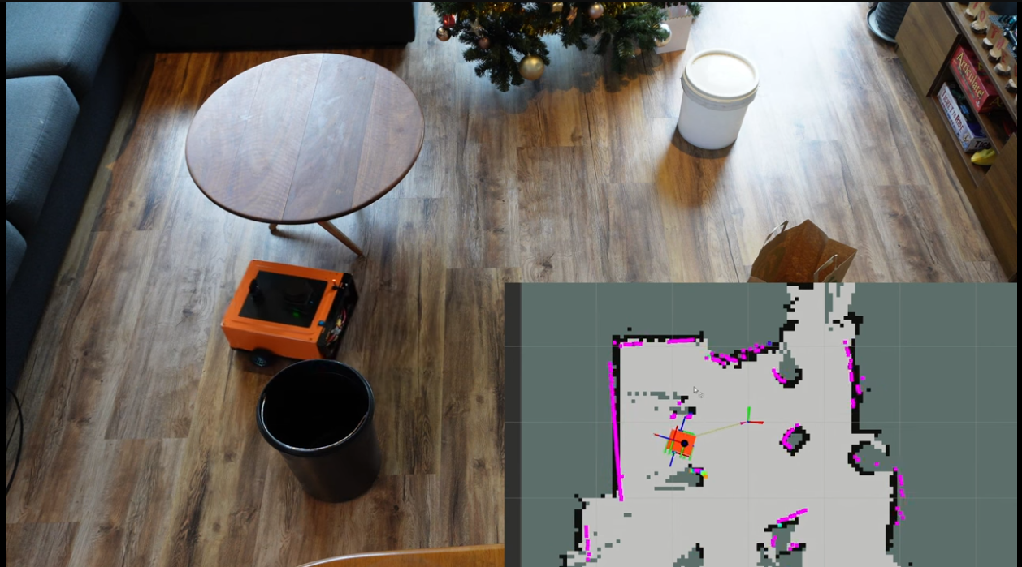
Figure 8. Building a SLAM-based map using ROS with the slam_toolbox node
Taken from the video: https://www.youtube.com/watch?v=ZaiA3hWaRzE
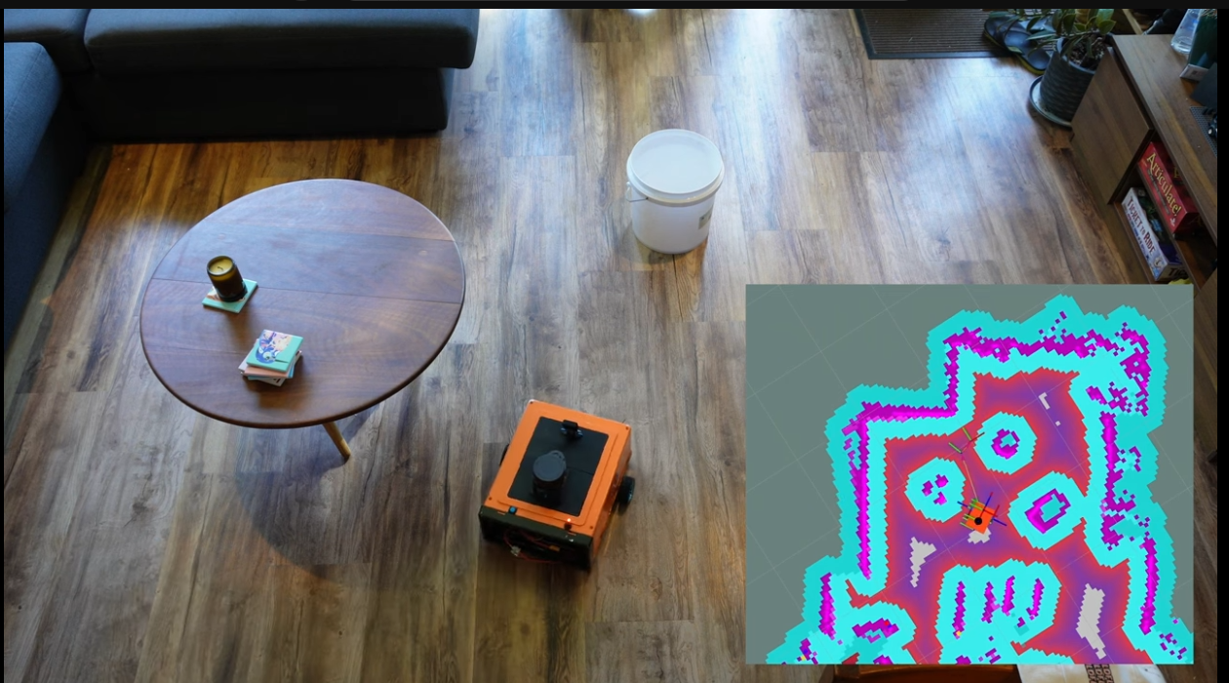
Figure 9.Loading the static map from the toolbox and navigating using NAV2
Taken from the video: https://www.youtube.com/watch?v=jkoGkAd0GYk

3.3.3 YOLOv8
YOLOv8 is a real-time object detection model that predicts bounding boxes and class probabilities from an input image in a single forward pass. In this project it is used for the classes Person, Healthy Lettuce, Leaf Disease, Weed, Soil Rot with object detection only (no segmentation).
High-level model structure:
- Backbone: extracts multi-scale image features.
- Neck: fuses features across scales (feature pyramid / path aggregation style) to support both small and large object detection.
- Head: outputs bounding boxes and class scores (YOLOv8 is commonly treated as an efficient, modern anchor-free detector in practice).
Why YOLOv8s (Small) and not YOLOv8n (Nano) or YOLOv8m (Medium):
- YOLOv8n: faster but usually less accurate under greenhouse challenges (occlusion, lighting variation, clutter).
- YOLOv8m: potentially more accurate but heavier for embedded real-time constraints (runtime and memory).
- YOLOv8s provides the best quality–speed tradeoff observed on Raspberry Pi 5 + Hailo-8, keeping real-time throughput while improving detection quality compared to Nano.
Deployment pipeline:
- Train and export to ONNX (Open Neural Network Exchange) → compile to HEF (Hailo Executable Format) using Hailo DFC (Dataflow Compiler) → run inference in a GStreamer pipeline on Raspberry Pi 5 + Hailo-8.

3.1.4 AI Algorithm Development (detection pipeline)
This research project develops an embedded, real-time object detection pipeline for greenhouse monitoring under limited edge hardware. The operational detection classes are: Person, Healthy Lettuce, Leaf Disease, Weed, and Soil Rot. The system uses object detection only (bounding boxes + class + confidence), without segmentation, to keep inference fast and deployable on Raspberry Pi 5 + Hailo-8.
Datasets (Roboflow).Two labeled datasets are used in Phase A.
(1) A lettuce disease dataset with 650 images and 7 classes (Bacterial, Downy mildew, Powdery mildew, Septoria blight, Viral, Wilt/leaf blight, Healthy). These labels are mapped to the project-level classes Healthy Lettuce and Leaf Disease.
(2) A lettuce–weed dataset with 1059 images and 2 classes (Plantweed, Lettuce) to support the Weed class.
Model and training. The selected model is YOLOv8s, chosen after practical tests because it provided the best quality–speed tradeoff when deployed with Hailo-8 in a C++ runtime. Training was performed in Google Colab using transfer learning (fine-tuning the YOLOv8s backbone). Input resolution is fixed to 640×640 to match the embedded runtime. Training hyperparameters (epochs, batch size) will be finalized and reported in Phase B.
Deployment on Pi 5 + Hailo-8. The trained model is exported to ONNX, compiled to HEF using the Hailo Dataflow Compiler (DFC), and executed in a GStreamer inference pipeline. Runtime resolution is 640×640. Measured throughput is 1–3 FPS on Raspberry Pi 5 without the accelerator and 20–30 FPS with Hailo-8 (up to ~30 FPS inference in the final pipeline).
Outputs and logging. Each detection returns bounding box, class, and confidence. Results are logged per row/planter for later analysis. During Phase A, an event is logged when Weed or Leaf Disease is detected with confidence ≥ 0.70, to capture cases for improvement (lighting, camera angle, and training coverage) before final threshold tuning in Phase B.
Expected metrics (Phase B targets). Phase B will measure detection quality and real-time feasibility. Target values are based on related results reported for YOLO-based detection in leafy-green diagnosis systems and for weed detection in complex/occluded environments (Abbasi et al., 2023; Goyal et al., 2024).
These targets will be validated in Phase B using standard detection metrics (mAP, precision, recall) and embedded metrics (FPS, latency) to evaluate whether the low-power Pi 5 + Hailo-8 setup can provide reliable real-time monitoring in the greenhouse.

3.1.5 Navigation and Localization Development (LiDAR + IMU)
Navigation in the greenhouse is performed without GPS, using a 2D ToF LiDAR (YDLIDAR T-mini Pro Plus) and an MPU-6050 IMU. The LiDAR provides 2D range scans for corridor detection and obstacle awareness. The IMU provides angular-rate and acceleration signals used to stabilize heading estimation during motion (especially turns and short LiDAR dropouts).
Sensors and interfaces. The LiDAR is connected to the Raspberry Pi 5 through a UART-to-USB serial interface and powered by a dedicated 5 V / 1000 mA supply. The IMU is read continuously to estimate yaw-rate and short-term orientation changes.
Navigation routine (row-by-row). The robot follows a structured routine: (1) align to a corridor between planters, (2) drive forward while keeping a centered distance to the corridor borders, (3) stop at the end of the row, (4) execute a turn, and (5) enter the next corridor. LiDAR scans are used to keep the robot centered and to detect obstacles in front of the robot. The IMU is used to improve turn consistency and to reduce heading jitter during forward motion.
3.1.6 Prototype Integration (robot ↔ server/website)
The prototype was integrated end-to-end so the robot can report greenhouse findings to a dedicated web dashboard used by the farm manager (Keren) for daily greenhouse operation and decision-making. The Raspberry Pi 5 runs the detection and navigation modules, generates detection outputs (class + confidence + timestamp), and links each record to a row/planter ID and scan cycle.
Internet connectivity is provided by a TP-Link M7200 4G LTE Wi-Fi modem. During operation, the robot logs all detections locally and uploads abnormal events (e.g., Weed or Leaf Disease with confidence ≥ 0.70) to the backend using a lightweight API message format. The server stores the updates and presents them on the website as row/planter status and an event history, enabling Keren to identify problems early and plan the required actions. If the connection drops, the robot keeps buffering records locally and retries upload when the network returns.
Phase B measurable targets: event-to-server upload latency ≤ 5 s on average, ≥ 95% successful delivery within 30 s, and no data loss during disconnections of up to 30 minutes (validated by comparing local logs to server records).

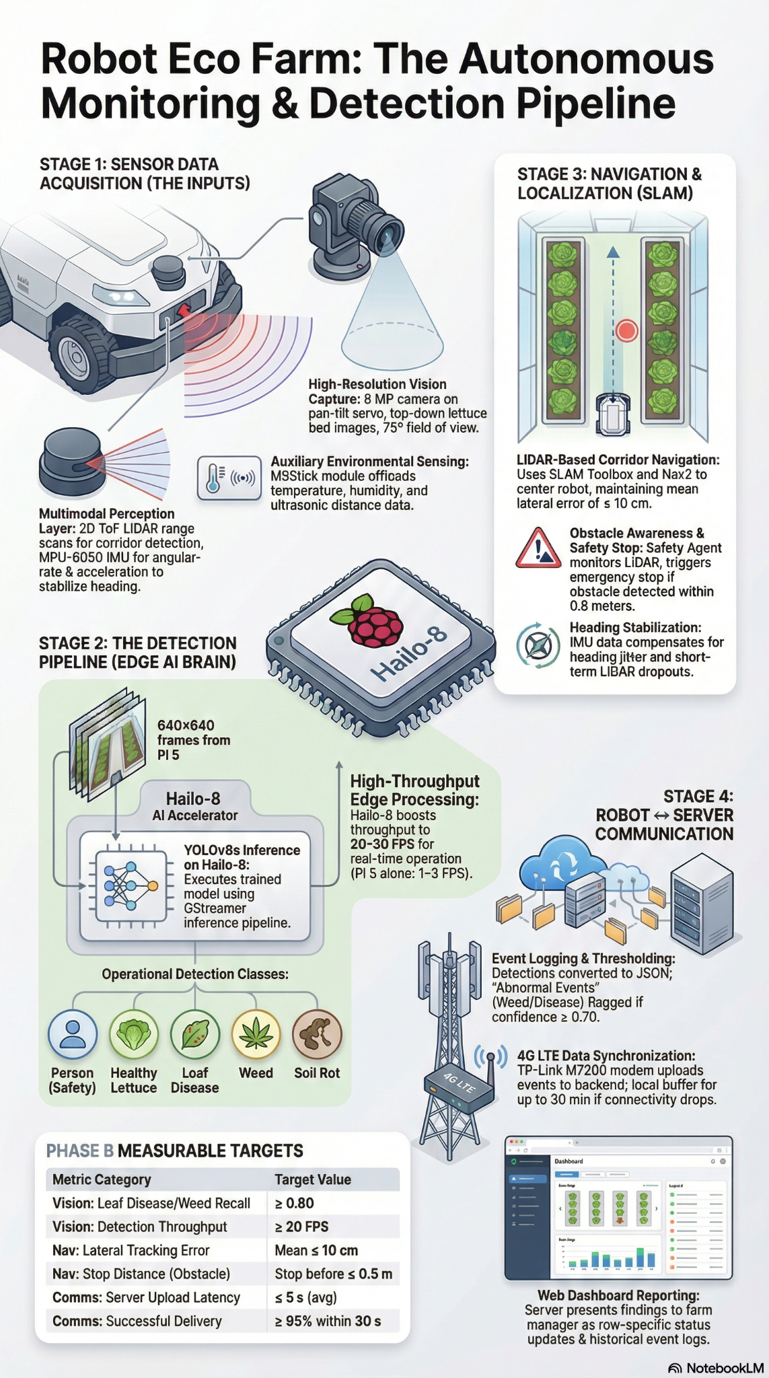
Figure 10 summarizes the end-to-end greenhouse workflow: the robot navigates row-by-row using LiDAR + IMU, captures camera frames, and runs YOLOv8s on Raspberry Pi 5 + Hailo-8 to detect key classes (e.g., healthy lettuce, disease, weeds). Abnormal detections are logged with row/location details and uploaded to the server/web dashboard, with local buffering and retry in case of network drops.

3.4 Diagrams
3.4.1 Use Case Diagram
- Main actors: Farm Manager (customer), User (views results), Admin (development team responsible for maintenance).
- Robot activities in the greenhouse: runs scan missions, collects sensor data, detects weeds or disease, optionally builds a map, and uploads scan reports to the server.
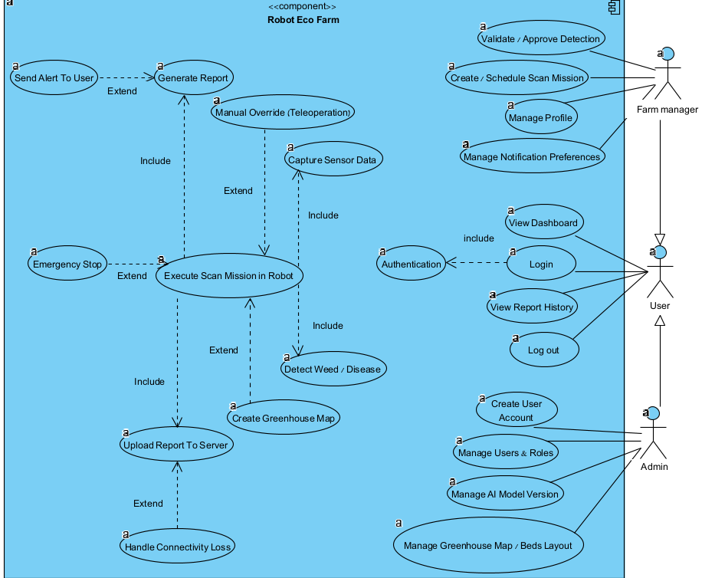
Figure 11. USE CASE diagram for both the robotic system and the website system

3.4.2 Architecture Diagram (robot structure, sensors, software)
(see Figure 12) summarizes the Robot Eco Farm architecture in a client–server model. The rover runs ROS 2 Humble as modular microservices (sensor acquisition, AI inference, navigation, and event generation). Detected events are published from the robot to the server through Cloud MQTT. The backend then exposes a REST API used by the web client (ReactJS) to fetch results and system status. Data is stored in Firebase, including authenticated access control.
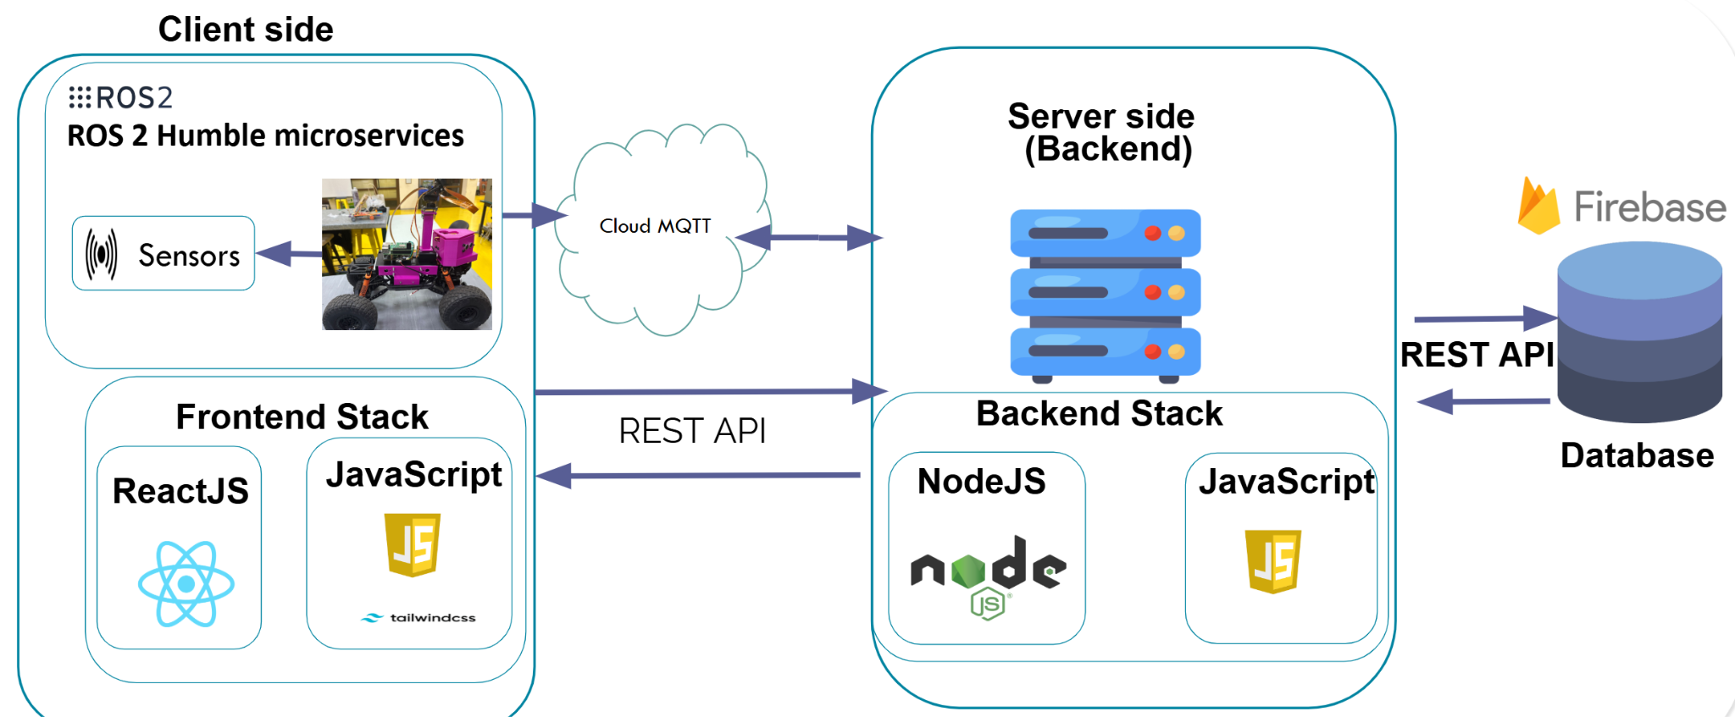
Figure 12.Client-server and Robot Architecture Using Microservices with ROS2
3.4.3 Activity Diagram (Scan & Reporting)

Figure 12 summarizes the scan-and-reporting workflow using four swimlanes: Robot Navigation, Edge AI (Camera + Hailo), MQTT Broker, and Node.js + Database. The robot starts from a reference point, scans each row while the camera direction is set by head orientation (left/right), and continuously captures frames for YOLOv8s inference and post-processing. When weed or disease is detected, a scan-report payload is created and published to the MQTT topic “scan report.” The broker forwards the message to the Node.js service, which validates it and either stores the record in the database or logs an error. The robot repeats this loop across rows with U-turns between corridors and finally returns to the start point to complete the mission.

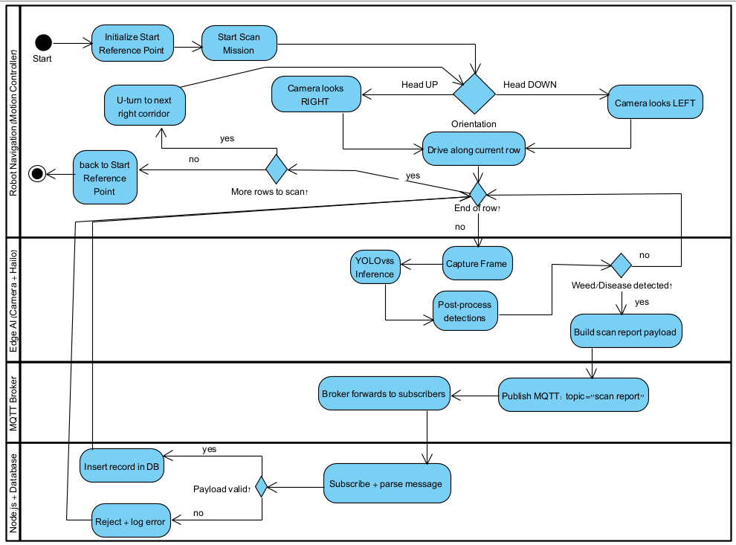
Figure 13. Activity_Diagram_Robot Scan_MQTT_Reporting

3.5 Expected Challenges
This project integrates an autonomous 4×4 greenhouse rover (Raspbot V2), edge AI inference (Raspberry Pi 5 + Hailo-8), LiDAR-based navigation/mapping, and a web dashboard connected through a REST API. Because validation happens in a real community greenhouse in Karmiel, the main expected challenges are strongly tied to real-world operating conditions and end-to-end integration.

1) Greenhouse lighting, background, and occlusions
The greenhouse environment includes strong daylight variation, reflections from white walls/floor covers, shadows, and frequent occlusions (dense lettuce leaves, equipment, workers). These factors can reduce YOLO detection stability and increase false positives/negatives, especially for subtle symptoms (early disease) and visually similar classes (weed vs leaf clutter).

2) Data collection and labeling for greenhouse-specific classes
Detection targets (healthy lettuce, leaf disease, weeds, and soil anomalies) require a labeled dataset that matches the exact greenhouse conditions. Challenges include class ambiguity, inconsistent symptom appearance across growth stages, and class imbalance (few disease cases compared to many healthy plants). Achieving the required mAP/Precision/Recall in “real greenhouse tests” depends heavily on consistent labeling rules and a fixed dataset split for evaluation.

3) Edge-AI pipeline constraints on Raspberry Pi 5 + Hailo-8
Even with Hailo acceleration, real-time performance can be limited by pre-processing, post-processing, memory bandwidth, camera I/O, and CPU load from concurrent tasks (motor control, logging, networking). Maintaining stable throughput (e.g., target FPS and inference latency) during robot motion—while also creating events and uploading results—can be a bottleneck that requires careful optimization and profiling.

4) Robust row-based navigation with LiDAR and repeatable geometry
Greenhouse rows often look geometrically repetitive, which can affect SLAM/localization stability and corridor tracking (especially after turns). Wheel slip, uneven surfaces, and narrow turning spaces may produce drift and unstable pose estimates. Reliable obstacle handling (detect at ~0.3 m and stop safely before ~0.1 m) is also challenging without causing excessive false stops.

5) End-to-end timing and scan mission completion within operational limits
A key operational target is completing a full scan cycle within a defined time window (e.g., ≤ 20 minutes). In practice, scan time is affected by navigation speed, stopping behavior, inference load, and network delays. Coordinating these components so the “scan mission” consistently completes on time is a system-level challenge rather than a single-module issue.

6) Network reliability (4G/Wi-Fi), latency, and guaranteed delivery
Connectivity inside a greenhouse can be unstable. Uploading results to the website with acceptable latency requires robust retry logic and buffering. A critical challenge is guaranteeing no data loss during disconnections (e.g., up to 30 minutes) and ensuring that buffered events are uploaded later in the correct order with consistent identifiers.

7) Consistent interfaces and fixed JSON schema across robot ↔ server ↔ website
The project depends on clean integration boundaries: event payloads, map export format, and identifiers (row/planter IDs). Maintaining a fixed JSON schema while the system evolves is difficult; small changes can break the web dashboard or data storage. Versioning, validation, and backward compatibility become essential to avoid integration regressions.

8) Runtime configurability without recompilation
Operational parameters such as confidence thresholds (e.g., abnormal-event threshold default 0.70) must be adjustable without rebuilding the robot software. Implementing safe configuration loading, validation, and dynamic updates—while ensuring changes are reflected immediately in runtime decisions—is a frequent source of bugs and test complexity.

9) Safety controls and reliable manual override
Because the robot operates around people and equipment, safety is a priority. Emergency stop/manual override must interrupt autonomy quickly and consistently (e.g., within ≤ 1 second). Ensuring safety behavior works under all modes (autonomous scan, mapping, manual driving) and under partial system failures (e.g., network down) is challenging.

10) Field testing, ground truth creation, and acceptance validation
Meeting acceptance criteria requires repeatable tests and strong evidence: mission logs, timestamp comparisons (robot vs server), evaluation reports (mAP/Precision/Recall), and navigation traces. In a real greenhouse, collecting ground truth and running controlled experiments (obstacles, turns, disconnections) takes time and must be carefully planned to produce defensible results.

4.Tests and metrics

4.1 Success Metrics and Acceptance Criteria
This section defines measurable criteria used to validate the system in greenhouse operation. Each metric is verified via repeatable tests and documented evidence (logs, evaluation reports, and exported artifacts). A requirement is accepted only if results meet or exceed the target under the defined test conditions.

Field Operation
Scan cycle time: Full scan mission time ≤ 20 minutes.
Evidence: Mission log with start/end timestamps + upload completion timestamp.
Data completeness: 100% of uploaded events include a valid row/planter ID.
Evidence: Server event records + automated check showing zero missing IDs.
Map export: Map is exported as JSON with a fixed schema (validation passes).
Evidence: Stored JSON file + schema validation output (pass).

Perception (Detection) – Phase B
Person detection: Recall > 0.85 (greenhouse tests).
Healthy lettuce: mAP@0.5 ≥ 0.85.
Leaf disease: mAP@0.5 ≥ 0.80, Precision ≥ 0.80, Recall ≥ 0.80.
Weeds: mAP@0.5 ≥ 0.80, Precision ≥ 0.80, Recall ≥ 0.80.
Soil rot: mAP@0.5 ≥ 0.75 (dataset-dependent).
Evidence (for all): Dataset version + fixed split + evaluation report (mAP/Precision/Recall) generated from labeled ground-truth tests.

Events
Abnormal-event threshold: Default confidence threshold 0.70, configurable without recompiling.
Evidence: Configuration file/UI/REST setting change + log showing updated threshold applied during runtime.

Navigation & Localization – Phase B
Path accuracy: Lateral error mean ≤ 10 cm, max ≤ 20 cm (straight mission).
Obstacle safety: Detect at 0.3 m, stop before ≤ 0.1 m, false-stop rate ≤ 5%.
Turning: Turn error < 10°, corridor re-acquisition ≤ 5 s.
Evidence (for all): Run logs + localization/pose trace + obstacle test runs with measured distances and stop timing.

Integration & UI
Communication latency (4G): Avg ≤ 5 s, and ≥ 95% delivered within 30 s.
Disconnection tolerance: No data loss for disconnections up to 30 min (buffering).
Manual override: Interrupt autonomy within ≤ 1 s.
Evidence (for all): Robot timestamps vs server receive timestamps + buffered queue logs + override timing logs.

Edge AI / Security
Inference performance: ≥ 20 FPS @ 640×640, latency 40–80 ms (Raspberry Pi 5 + Hailo-8).
Evidence: Profiling logs (FPS + latency distribution) captured during real mission workload.
Secure transport: Communication uses HTTPS/TLS.
Evidence: Server configuration + verified TLS connections (e.g., connection logs / certificate-based session).

References
Abbasi, R., Martinez, P., & Ahmad, R. (2023). Crop diagnostic system: A robust disease detection and management system for leafy green crops grown in an aquaponics facility. Artificial Intelligence in Agriculture, 10, 1–12. https://doi.org/10.1016/j.aiia.2023.09.001
Elstone, L., How, K. Y., Brodie, S., Ghazali, M. Z., Heath, W. P., & Grieve, B. (2020). High speed crop and weed identification in lettuce fields for precision weeding. Sensors, 20(2), 455. https://doi.org/10.3390/s20020455
Fishman, N., Yungstein, Y., Yaakobi, A., Obersteiner, S., Rez, L., Mulero, G., Michael, Y., Klein, T., & Helman, D. (2025). Leaf water potential in a mixed Mediterranean forest from machine learning and unmanned aerial vehicle (UAV)-based hyperspectral imaging. Remote Sensing, 17(1), 106. https://www.mdpi.com/2072-4292/17/1/106
Goyal, R., Nath, A., & Niranjan, U. (2025). Weed detection using deep learning in complex and highly occluded potato field environment. Crop Protection, 187, 106948. https://doi.org/10.1016/j.cropro.2024.106948
Guerrero-Higueras, Á. M., Álvarez-Aparicio, C., Martínez-Cámara, E., de la Cal, E., & Matellán, V. (2019). Tracking people in a mobile robot from 2D LIDAR scans using full convolutional neural networks for security in cluttered environments. Frontiers in Neurorobotics, 12, 85. https://www.frontiersin.org/journals/neurorobotics/articles/10.3389/fnbot.2018.00085
Li, Q., & Zhu, H. (2024). Performance evaluation of 2D LiDAR SLAM algorithms in simulated orchard environments. Computers and Electronics in Agriculture, 221, Article 108994. https://www.sciencedirect.com/science/article/pii/S0168169924003855
Li, Z., Li, Y., Yang, Y., Guo, R., Yang, J., Yue, J., & Wang, Y. (2021). A high-precision detection method of hydroponic lettuce seedlings status based on improved Faster RCNN. Computers and Electronics in Agriculture, 182, 106054. https://doi.org/10.1016/j.compag.2021.106054
Macenski, S., & Jambrecic, I. (2021). SLAM Toolbox: SLAM for the dynamic world. Journal of Open Source Software, 6(61), 2783. https://doi.org/10.21105/joss.02783
Mohanty, S. P., Hughes, D. P., & Salathé, M. (2016). Using deep learning for image-based plant disease detection. Frontiers in Plant Science, 7, 1419. https://doi.org/10.3389/fpls.2016.01419
Ni, C., Cai, J., & Wang, P. (2025). A LiDAR SLAM and Visual-Servoing Fusion Approach to Inter-Zone Localization and Navigation in Multi-Span Greenhouses. Agronomy, 15(10), 2380. https://www.mdpi.com/2073-4395/15/10/2380
Pham, C.-C., & Lin, W.-C. (2025). Development and field evaluation of a UWB-IMU navigated autonomous spraying robot for papaya greenhouses. Smart Agricultural Technology, 12, 101267. https://www.sciencedirect.com/science/article/pii/S2772375525004988
Wang, Y., Wu, M., & Shen, Y. (2024). Identifying the growth status of hydroponic lettuce based on YOLO-EfficientNet. Plants, 13(3), 372. https://doi.org/10.3390/plants13030372
Yoo, H., Baek, D., & Choi, S.-g. (2024). Navigation path following platform for a greenhouse shuttle robot using the Stateflow method. Mathematical Problems in Engineering, 2024, Article 8810990. https://onlinelibrary.wiley.com/doi/10.1155/2024/8810990

Appendix A:
Test ID | Function Under Test | Preconditions / Setup | Test Step | Expected Result | Evidence / Output
FT-01 | Execute Full Scan Mission | Robot powered, camera + LiDAR ready, server reachable | Start “Scan Mission” → robot completes route → results uploaded | Mission completes end-to-end and results appear on website | Mission log (start/end), server upload log, event list screenshot/export
FT-02 | Event Upload Includes Row/Planter ID | Row/planter mapping configured | Run short scan producing multiple events | Every uploaded event contains valid row/planter ID | Server DB/API dump showing 0 missing IDs
FT-03 | Map Generation + JSON Export | Mapping enabled; schema file/version defined | Run “Create Greenhouse Map” mission → export map | JSON exported and matches fixed schema (validation pass) | JSON file + schema validation report
FT-04 | Detection Event Creation (AI → Event) | Detection pipeline running | Present known target(s) (person/lettuce/disease/weed) in view | System generates event(s) with bbox/class/confidence | Event log with detection payload (class, confidence, bbox)
FT-05 | Abnormal Event Threshold Configuration | Threshold configurable source exists (config/UI/REST) | Set threshold=0.70 → run; change threshold → run again | Threshold applied at runtime without recompiling; behavior changes accordingly | Config change record + logs showing threshold value used
FT-06 | Straight Navigation Corridor Tracking | Corridor/row defined; localization running | Run straight mission segment | Robot follows corridor and remains stable (no unsafe drift) | Pose trace + path log (for later analysis)
FT-07 | Obstacle Detection & Safe Stop | Obstacle placed; distance sensing active | Drive toward obstacle; verify detection at ~0.3 m | Robot stops before reaching ≤0.1 m distance; stop is triggered reliably | Distance readings + stop command timestamp log
FT-08 | Turn + Corridor Re-acquisition | Intersection/turn point defined | Command a turn maneuver during mission | Robot completes turn and re-acquires corridor tracking | Heading/pose logs + time-to-stabilize marker
FT-09 | Robot → Server → UI End-to-End Delivery | Cellular/4G (or network shaping) available | Generate N events during motion | Events appear on UI; delivery latency within target window | Robot timestamps + server receive timestamps; UI record list
FT-10 | Offline Buffering (No Data Loss) | Local queue/buffer enabled | Disconnect network for up to 30 min while generating events → reconnect | All buffered events upload after reconnection with no missing records | Queue log + before/after counts; server confirms all events received
FT-11 | Manual Override / Emergency Stop | Manual control input available | During autonomy, trigger manual override | Autonomy stops and control switches immediately | Input timestamp + motor/autonomy state change log
FT-12 | Secure Communication (HTTPS/TLS) | Server configured for TLS | Perform login/upload/API calls | All traffic uses HTTPS/TLS; no plaintext endpoints used | Server config evidence + connection/security logs (TLS session)

3.2 (All project requirements)
Area | Req No. | FR (Atomic) | NFR (Constraints + Classification)
Field Operation | 1 | Scan greenhouse corridors row-by-row. | Performance:  Complete a full scan cycle of all planters within ≤ 20 minutes.
 | 2 | Create a greenhouse map during scanning (row/corridor map). | Interoperability:  The generated map shall be saved and exported as a JSON file using a fixed schema (e.g., corridors/rows, row IDs, geometry/poses).
 | 3 | Assign each scan result to a row/planter ID. | Reliability:  Row/planter ID must be recorded for 100% of uploaded events.
Perception (Object Detection) | 4 | Detect Person in camera frames. | Performance:  Person Recall ≥ 0.85 in greenhouse tests (Phase B).
 | 5 | Detect Healthy Lettuce in camera frames. | Performance:  mAP@0.5 ≥ 0.85 for Healthy Lettuce (Phase B).
 | 6 | Detect Leaf Disease in camera frames. | Performance:  mAP@0.5 ≥ 0.80 and Precision/Recall ≥ 0.80 for Leaf Disease (Phase B).
 | 7 | Detect Weed in camera frames. | Performance:  mAP@0.5 ≥ 0.80 and Precision/Recall ≥ 0.80 for Weed (Phase B).
 | 8 | Detect Soil Rot in camera frames. | Performance:  mAP@0.5 ≥ 0.75 for Soil Rot (Phase B, dataset dependent).
 | 9 | Output bounding box coordinates for a detection. | Interoperability:  Output is JSON with bbox fields (x,y,w,h) in pixel units and a fixed schema.
 | 10 | Output a class label for a detection. | Interoperability:  Class label must be one of the supported classes (Person, Healthy Lettuce, Leaf Disease, Weed, Soil Rot).
 | 11 | Output a confidence score for a detection. | Interoperability:  Confidence must be numeric in [0,1] (or 0–100%) and consistent across all detections.
 | 12 | Log an abnormal event when Weed or Leaf Disease is detected. | Performance:  Abnormal-event confidence threshold is 0.70 and is configurable via a settings file.
Navigation & Localization | 13 | Center the robot within a corridor using LiDAR feedback. | Safety/Performance:  Mean lateral error ≤ 10 cm and max ≤ 20 cm during straight motion (Phase B).
 | 14 | Stop the robot when an obstacle is detected ahead. | Safety:  Detect obstacle at ≥ 0.8 m and stop before ≤ 0.5 m; false-stop rate ≤ 5% of runs.
 | 15 | Execute an end-of-row turn and re-enter the next corridor. | Performance:  Turn angle error ≤ 10° and re-acquire corridor within ≤ 5 s (Phase B).
Integration (Robot↔Server) | 16 | Upload abnormal events to the backend server. | Performance/Interoperability:  Upload uses the cellular internet link (4G modem); average event-to-server latency ≤ 5 s; ≥ 95% delivered within 30 s (Phase B).
 | 17 | Store detection and event logs locally on the robot. | Reliability:  Local storage must support buffering during connectivity loss; no data loss for disconnections up to 30 minutes (Phase B).
 | 18 | Display uploaded events on a web dashboard. | Usability:  Dashboard supports row/planter status and event history; optimized for the farm manager’s operational use.
 | 19 | Support manual teleoperation of the robot. | Safety:  Teleoperation is provided via a USB gamepad; manual override interrupts autonomous motion within ≤ 1 s.
Performance (Edge AI) | 20 | Run object detection inference on the robot. | Performance:  Implementation uses YOLOv8s on Raspberry Pi 5 with Hailo-8 at 640×640; sustained ≥ 20 FPS; expected end-to-end latency 40–80 ms (Phase B).
Maintainability | 21 | Allow configuration of thresholds without recompiling. | Maintainability:  All configurable parameters stored in a versioned config file;
 | 22 | Allow configuration of row IDs without recompiling. | Maintainability:  changes take effect after restart.
Security | 23 | Provide user authentication for the web dashboard. | Security:  Only authenticated/authorized users can access the dashboard; data transmission should use HTTPS/TLS.

